Adventure Quest – Course Work 1

Gabriel Yong

University of Nottingham

# Design

This game would take place in Jubilee campus and aims to provide new students to the University with a fun and engaging tour of the campus. The setting of the game would be medieval fantasy with wizards, dragons and other fantastical concepts. The game would be an alternate reality game in which users would assume the role of adventurer seeking to explore the kingdom (the university) and to vanquish the evil dragon in its lair. Players would start of weak but they would be able to gain powerful and magical items to help defeat the dragon by visiting pre-specified locations. A nonlinear design would be implemented in which players would be able to explore the campus whichever way they wish to, and players would be able to obtain sufficient items to defeat the dragon without having to visit all the areas.

Prior to entering the campus, players would be emailed with an instruction sheet on how to play the game. This information sheet would contain a link to the virtual map of the school as well as the link needed to access the tutorial metaverse page. Upon entering the school, players can check the map and decide which point they would like to start their journey from. The ideation cards listed below helped shape and guide the game during the design stage till the final stages.

**Design sketch**

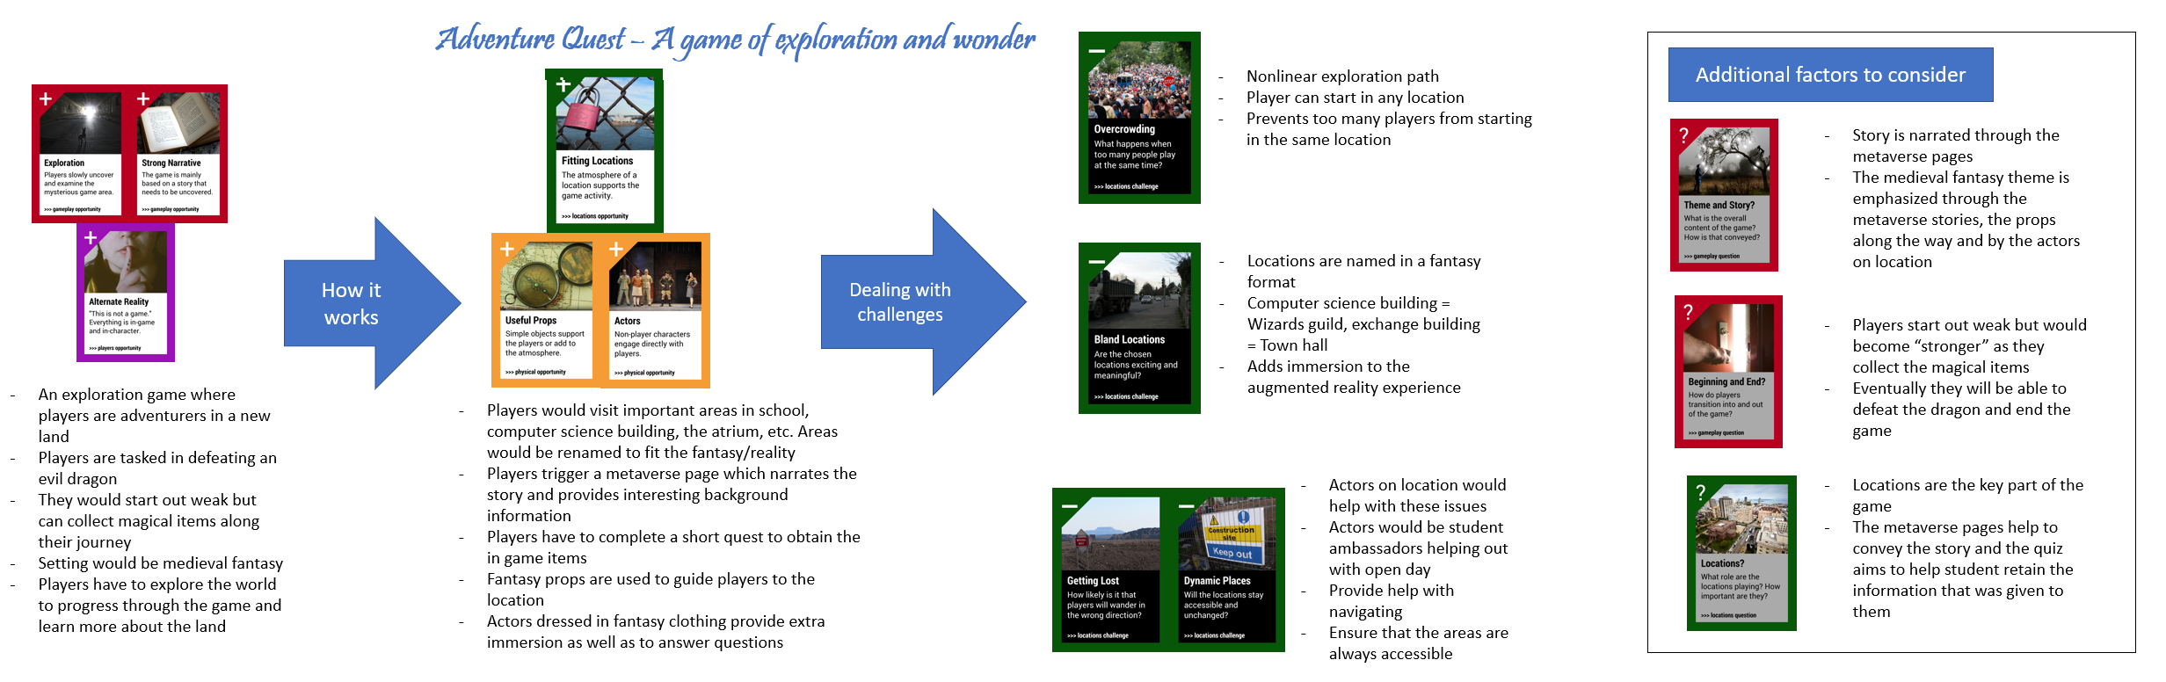

**Prototype**

**Location summary**

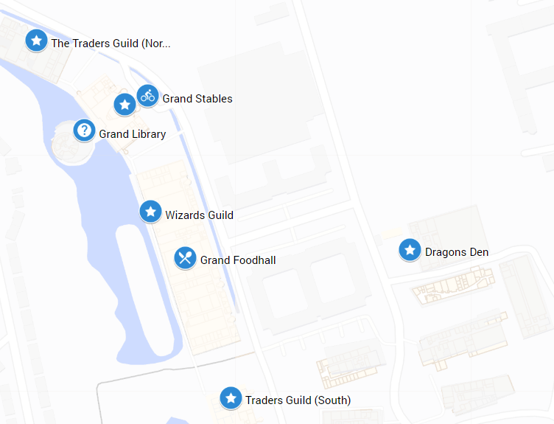

The locations identified for the game would be important areas that the student will need to know during their time in the university. In the figure above, these are some of the locations that were chosen for the game. To aid with immersion, buildings in the game world would share similar functions to the real-world buildings. For example, the atrium canteen would be called the “Grand Food-hall” and the computer science building will be called the “Wizards Guild”. The trigger points were located at high traffic paths which students would often take. For locations with multiple entrances (e.g., The atrium), the trigger point would be located in the center and since the trigger radius is 30 meters, players would be able to access it from both sides. For locations that have restricted access (e.g., Computer science building), the trigger point will only be located at the common areas that can be accessed by anyone.

**Photostory**

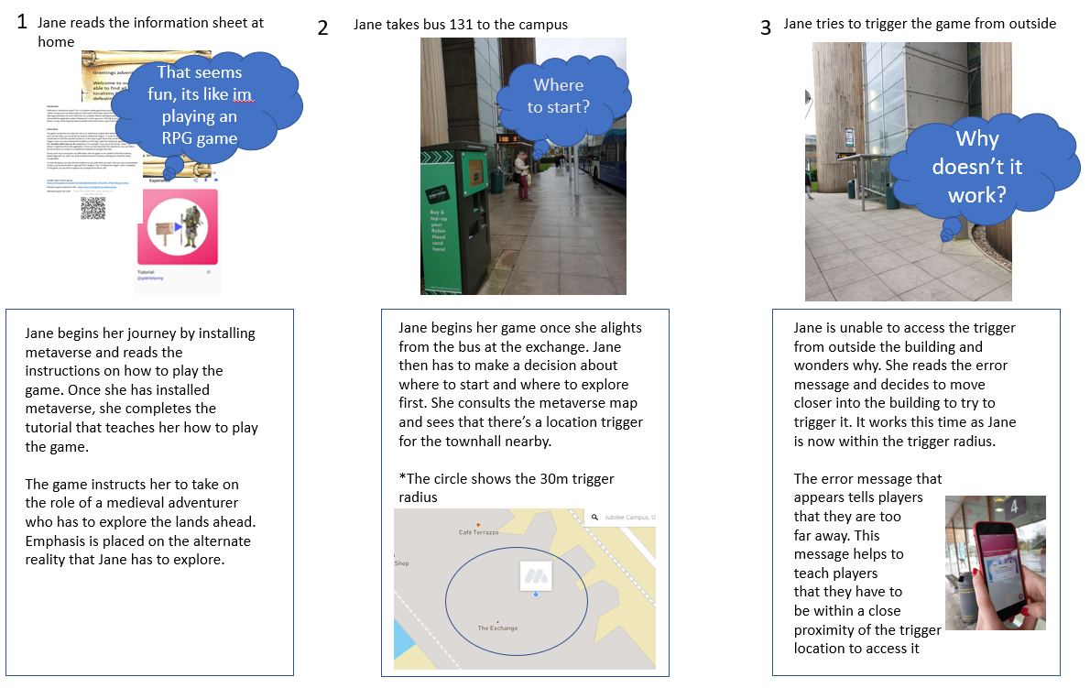

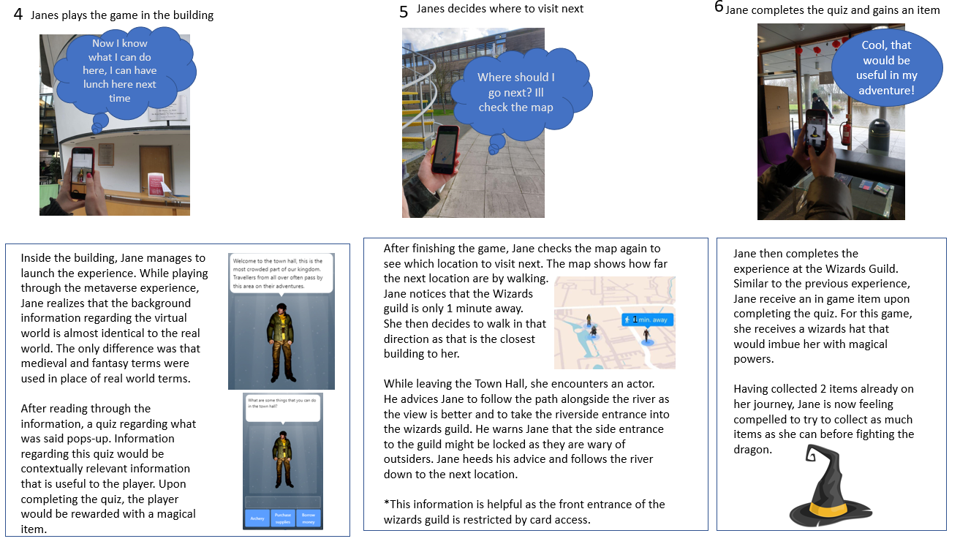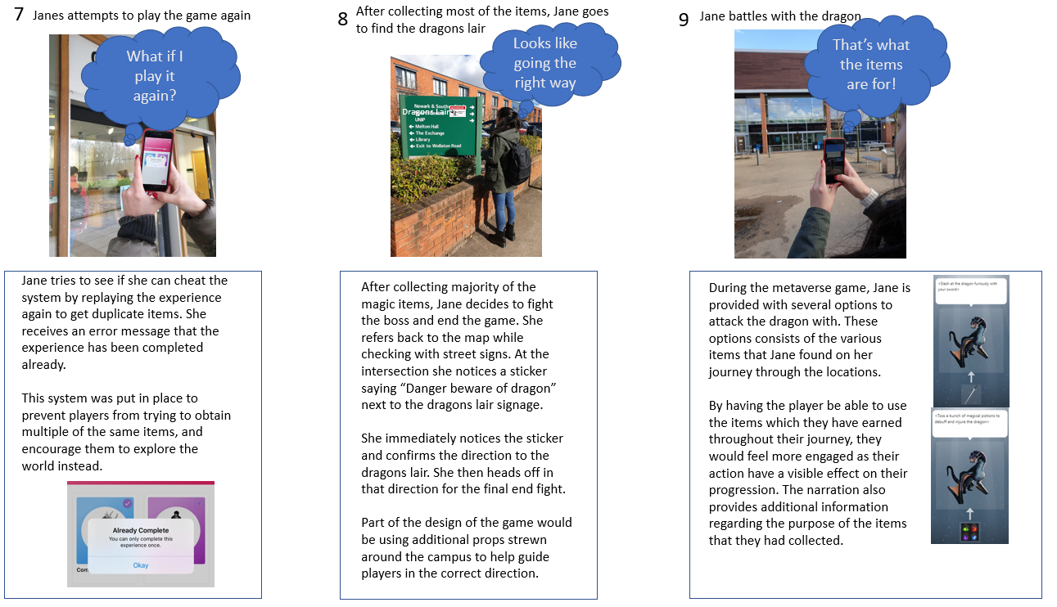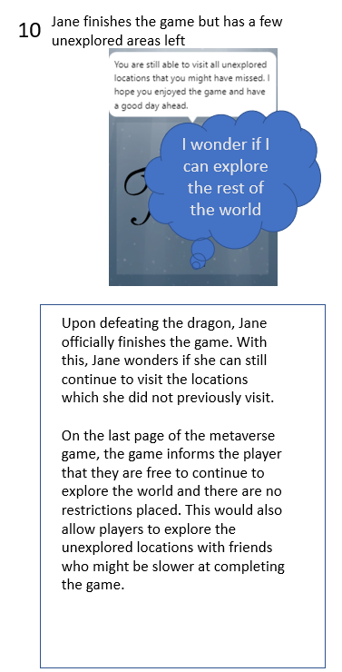

**Implementation**

The prototype was implemented using the various metaverse experiences on an apple and android phone system. The two different phone systems were tested to ensure that location sensitivity was constant between phone operating systems. The game was tested on an iPad as well to ensure that the experience was the same when viewed on an iPad. The location triggers went through multiple iterations whereby the trigger point was adjusted to encompass a more suitable area.

The mode of travel was considered for how players would arrive at the destination and which entrance they would most likely take. For users who take the bus in, they would most likely arrive at the exchange building while those who walk in would arrive through the entrance along Triumph Road. Although the game used a non-linear play style, the locations chosen were all situated around those locations so players would not need to travel backwards and forwards too much. Once the locations were finalized, the prototype was initially tested by me and then by a group of friends who play tested the experience to check for any errors or bugs.

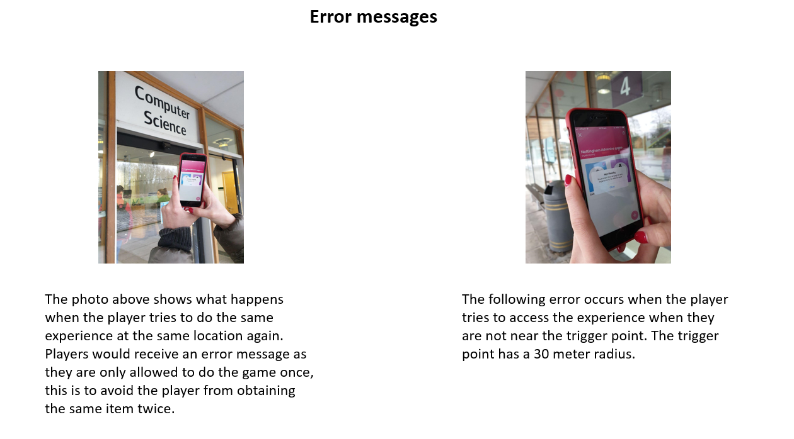

Two features were implemented to prevent players from getting an unfair advantage in the game. Firstly, players were not allowed to do the same experience by visiting the same area more once. This was done to stop players from obtaining the same item multiple times. Secondly, players were not allowed to access the locations until they were 30 meters from the trigger point. This was done so that players would have to physically be at that location to trigger the experience, rather than staying in one location and triggering all the experiences at once. Players would receive an error message if they tried to do these.

**Testing**

The main component during testing were ensuring that all the location triggers as well as the trigger radius were in suitable positions. The radius was tested to compensate for any GPS drift that the players might experience. The next component was to ensure that the augmented reality experience was conveyed effectively through the metaverse experiences. This was done by having the play testers play through all the locations and to check for any gaps or errors in the metaverse pages. Several iterations of the metaverse pages were made to identify which pages did users prefer. Some minor changes were made to the story to enhance the immersive element of the game.

To break the assumptions as a designer, I had to play test the game through the perspective of someone who has not been to the school before and also has no experience in using any form of locative media technologies. Having the mindset of someone who has not been to the school before helped in ensuring that all the locations identified could be accessible to all players and did not require much effort in searching for them. The locations were all in easy to reach places and none of the trigger points were in inaccessible locations or locations that were out of the way to new students of the school. These locations could also be easily identified a they could be found on street signs around the campus.

While running the prototype, the play testers mentioned that they felt a sense of accomplishment when they finished the quiz and were given the in-game item. They said that the visual feedback when the item appears on-screen was very satisfying and helped to aid with immersion. This highlighted the importance of feedback, especially visual cues, in providing a satisfying experience to the user. Auditory feedback however was not as relevant as not all users had their phone volume on during the game.

They also mentioned that the quiz was a good way of engaging the player as it required them to pay attention to the information presented to them. The immersive experience helped to sell the game as players said that they felt like they were actively participating. Two iterations of the quiz were prototyped, a more immersive quiz and a more factual quiz. The first quiz utilized questions told using a purely immersive and fantasy-based approach and did not detract from the augmented reality experience. The second quiz however broke the immersion by using real life examples in the questions. Players preferred the first iteration as they felt that it was a more engaging way of getting users to feel immersed in their surroundings.

One criticism that could be explored in further detail in the future was that the game was relatively simple as it was a modification of a scavenger hunt with a slight twist, further iterations could build on the complexity by adding in additional components. Additional side quests could be implemented that would direct players to specific parts of the school to search for specific items. As the distance between certain location are long and users might not have anything to do during these periods of down time, these side quests would provide an additional source of interaction for the player to experience while still having the primary goal in mind.

**Analysis of challenges**

As the core of the gameplay revolved around locative media, several location issues have to be addressed. Myhill (2004) postulated on the idea of *desire lines* which were the users most optimal path to a destination. By analyzing the ideal path that users take around the school, the locations for the game were situated in a way that players could easily get between locations conveniently. In addition, it was important to identify the way in which the experience was staged (Bedwell, 2016). As the campus contains multiple entrances and students have multiple modes of transport into the campus, it would be difficult to identify a singular starting point for all students. To deal with this issue, a non-linear game was developed. This non-linearity allows players to start at any point on the map. This also deals with the issue of overcrowding, as the starting zone could get very crowded if all the players started in the same location.

Building on this issue is also the possibility of *orphaned content* (Bedwell, 2016). This was content that was ignored either due to there being no physical path to the location or because it was too far from all other locations. As the desire lines were quite well established in the campus, those being the footpaths that students take daily, it would be ideal to place the locations alongside such paths. To deal with this challenge, none of the locations were spread out too far from one another and they were all located alongside the main road.

Another issue that was considered was the issues with registration. The initial prototype consisted of the player having to view the metaverse AR at specific viewing parameters. Azuma (1997) stated that errors in viewing parameters can be caused by minor deviations in positions as well as the users eye level. Although this issue could not be easily rectified without making heavy adjustments to the game process or by having a tedious process in which players have to be meticulously positioned. An alternative option for this would be for the AR sprites to be transformed into flat 2D images. Although this might break immersion, it would still be able to provide the same narrative experience a before.

Designing for seams were integral in the development of a location-based game. Benford and colleagues (2006) talks about the importance in designing for the situation where the technology would not work. The locations identified were near areas with Wi-Fi access so even if there was no 3G/4G access, players would still be able to access the internet at these spots. Uncertainty was also managed by using orchestration (Benford et al, 2006), whereby actors on location help to bridge uncertainty. The actors would be dressed accordingly and also be instructed to roleplaying as though they are part of the augmented reality. If the players don’t have access to the internet or are unable to view their map, they can approach these actors to get help. In addition, the actors would also provide extra narration to the players while they are playing the game.

Overall, the biggest challenge to overcome were the challenges regarding locations. These challenges were largely overcome by carefully manipulating the location trigger areas and by placing actors at strategic locations to guide students away from the undesired path. In addition, the non-linearity of the game also addressed the challenge that players are highly likely to not follow the fixed path and instead explore the locations on their own accord.

References

Azuma, R. T. (1997). A Survey of Augmented Reality. *Presence: Teleoperators and Virtual Environments*, 355-385.

Bedwell, B. (2016). Reading and Responding to the Digital. *Architecture and Interaction*, 299-320.

Benford, S., Crabtree, A., Flintham, M., Drozd, A., & Paxton, M. (2006). Can You See Me Now? *ACM Transactions on Computer-Human Interaction*, 100-133.

Myhill C. (2004) Commercial Success by Looking for Desire Lines. In: Masoodian M., Jones S.,

Rogers B. (eds) Computer Human Interaction. APCHI 2004. Lecture Notes in Computer

Science, vol 3101. Springer, Berlin, Heidelberg

Tolmie, P., Benford, S., Flintham, M., & Brundell, P. (2012). “Act Natural”: Instructions, Compliance and Accountability in Ambulatory Experiences. *Session: Performative Emergency Simulation*, 5-10.

Appendix A

Promotional flyer for the game



Appendix B

Information sheet with background information regarding the game

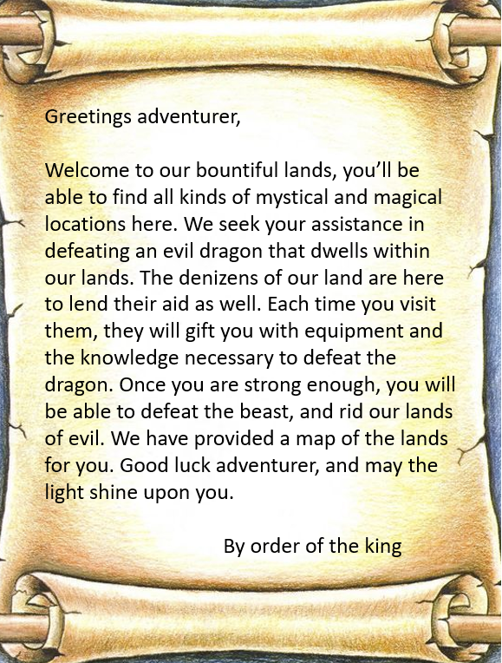

Appendix C

Map of the locations

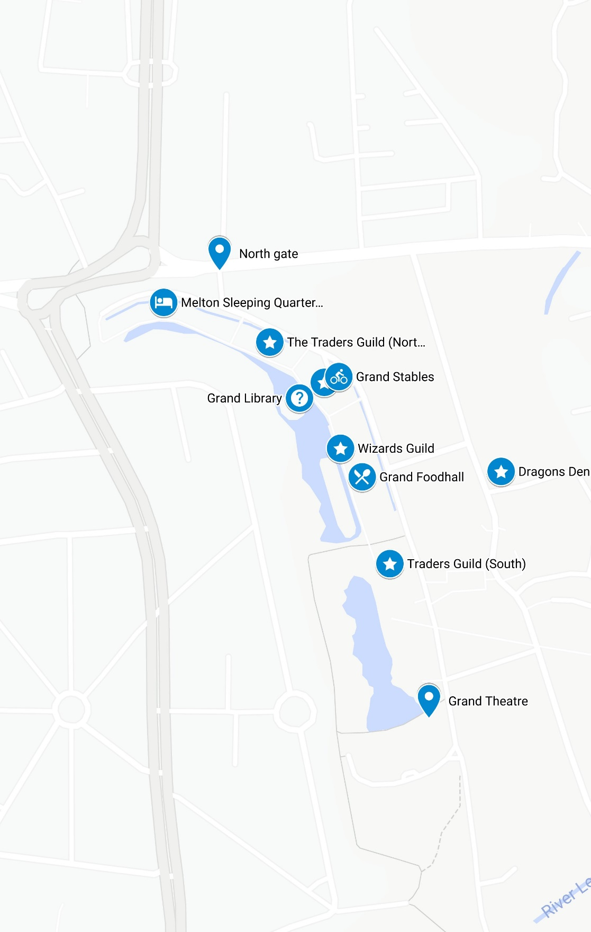

Appendix D

Information sheet

